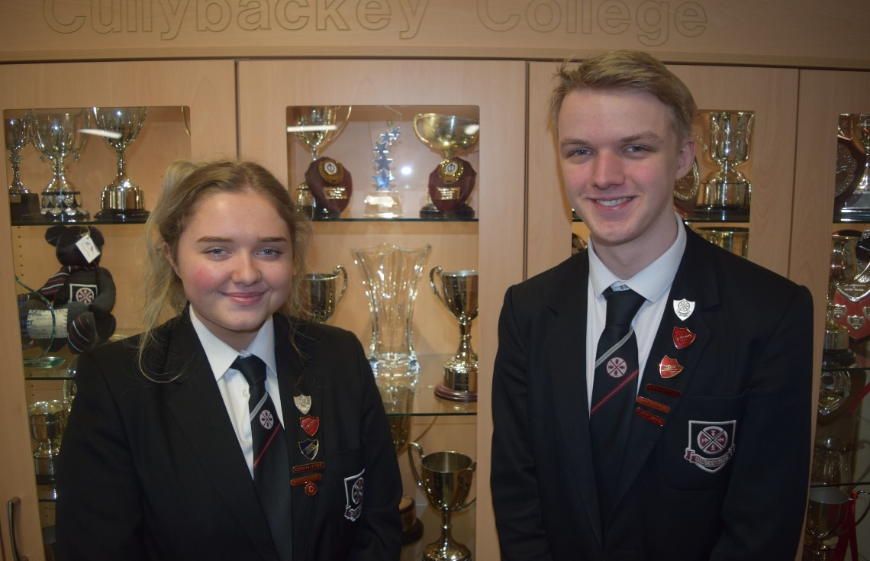



**Cullybackey College**



**Creating Opportunities for Success**

**Sixth Form  
Induction Booklet  
2023 - 2024**

****Welcome to Sixth Form**

Dear Student,

Welcome to Sixth Form.

I would like to give you a warm welcome to Cullybackey College Sixth Form. We are delighted that you have decided to continue your education in the Sixth Form at Cullybackey. The transition from GCSE courses to Sixth Form study represents a major hurdle, but it is a challenge which has been accepted confidently by Cullybackey College students in the past. Record results at GCSE have been accompanied by impressively strong AS and A2 Level grades in recent years. The very considerable ability of our students and the high quality of the advice which they receive from their teachers will contribute hugely to the impact that you can make in the Sixth Form.

This booklet outlines our expectations of you and what help and support you can expect from the Sixth Form Team. I am confident that your years in the Sixth Form will represent the culmination of your school career and give you an excellent platform for higher education and your future careers. The high achievements of A Level students from Cullybackey are a source of considerable pride as they leave to take up their places in the country’s leading universities. At the same time, they are enjoying the wide diversity of activities and interests that the school encourages, as well as the opportunity to take on leadership roles. I am sure that next year’s Year 13 will have appropriately high aspirations as you look forward to the opportunities offered to you over the next two years.

During your time in the Sixth Form we expect students to work hard and do their best in their academic studies. We want students to continue their development as reflective and effective individual learners who become increasingly self-aware about their learning and how it can be improved; demonstrate determination, resilience and perseverance in working towards challenging targets and exercise responsibility for their own learning, managing work schedules and meeting deadlines. We also expect students to develop further as social learners who can work collaboratively and cooperatively with other students in different groupings. I wish you every success as you embark on an exciting and challenging two years.

S Wright D Donaldson

Mrs S. Wright Mr D. Donaldson

Head of Senior School Principal

**Meet the main Sixth Form Staff**

|  |  |  |
| --- | --- | --- |
|  |  |  |
| **Mr WR Boyd** | **Mr D Donaldson** | **Mr T Manson** |

The **Principal, Mr D Donaldson** and **Vice Principals, Mr WR Boyd** and **Mr T Manson** along with senior staff generate strategies and improvements for the College. Heads of Department are responsible for the creation and development of the curriculum across the College. **Mr T Manson** has overall responsibility for the Sixth Form Curriculum.

|  |  |  |
| --- | --- | --- |
|  |  |  |
| **Mrs S Wright** | **Mrs L Patton** | **Mrs D Wilkinson** |

The **Head of Senior School** has overall responsibility for pastoral and academic matters related to senior students. The Head of Senior School is **Mrs S Wright**.

The **Year Head** has responsibility for the progress, behaviour, attendance and welfare of all pupils within their year group. **Mrs L Patton** is **Head of Year 13** and **Mrs D Wilkinson** is **Head of year 14** and **Head of Careers.**

|  |  |  |
| --- | --- | --- |
|  | The **Designate Child Protection Teacher** is **Mr C McLaren**  and the **Deputy** **Designate Child Protection Teacher** is **Mrs P Roulston.** They have responsibility for Safeguarding and Child Protection across the College. |  |
| **Mr C McLaren** | **Mrs P Roulston** |

**Sixth Form Expectations**

**Mrs J McDonald**

As a Sixth Form student at Cullybackey College **you can expect**:

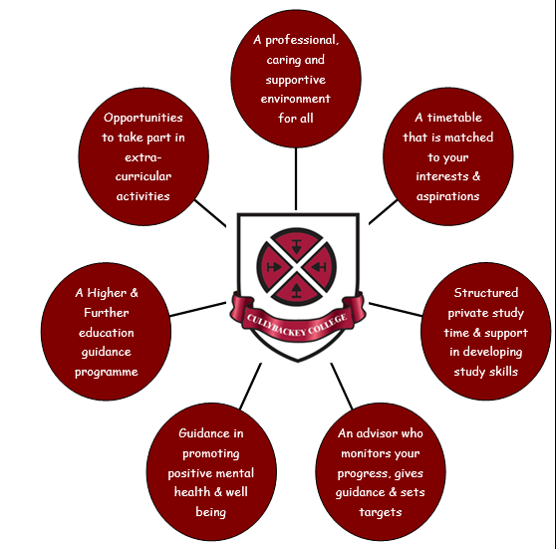

**“Together we can progress, succeed and achieve.”**

**Sixth Form Expectations**

As a Sixth Form student at Cullybackey College **you will be expected to**:

[](http://www.google.co.uk/url?sa=i&rct=j&q=&esrc=s&source=images&cd=&cad=rja&uact=8&ved=0ahUKEwjJ4pmO0LDUAhVGI8AKHX_zA-MQjRwIBw&url=http://www.barbarasunden.com/overwhelmed/&psig=AFQjCNFiq4tYM6qf3kNgOKtaHFcW_8h9Zw&ust=1497092917504969)

Be determined to make the most out of your time in Sixth Form.

Accept responsibility for your own learning.

Show enthusiasm and commitment for your own learning.

Take an active part in your lessons by: engaging in debate, listening to others, sharing your knowledge, helping others and developing your skills and capabilities outside class time.

Seek help and guidance when necessary.

Complete all your work to the best of your ability and by the deadline required.

Act as a positive role model for younger students in the College and the wider community.

Use your private study time in school to complete set work, conduct further research and read around a subject or topic.

Maintain high standards of uniform and strive to maintain a 100% attendance and punctuality record.

Contribute to the life of Sixth Form, as well as the whole school, in as many ways as possible.

**Making the jump from GCSE**

Making the move up from GCSE study to A Level is not always an easy one.

[](http://www.google.co.uk/url?sa=i&rct=j&q=&esrc=s&source=images&cd=&cad=rja&uact=8&ved=0ahUKEwik1aq1r67UAhXMbFAKHbIkA3IQjRwIBw&url=http://www.resourceaholic.com/2014/10/bridging-gap-to-level.html&psig=AFQjCNGYEbjw9K9u27VljB7a9a4DOt6BOQ&ust=1497015478064110)The transition will see you develop important new skills which will help you to succeed at Post-16. These skills are vital if you are to fulfil your potential and to build on your achievements at GCSE. They will help you to organise yourself and work towards achieving your goals within the time limits.

The key transitional skills are listed below:

**Note-taking**

Note-taking doesn’t have to mean pages and pages of writing. Construct your notes in a format which best suits your learning style. This could include:

* Short bullet-pointed points.
* Mind maps or concept maps.
* Paragraphs.

**Wider Reading**

All your subjects will expect you to carry out some wider reading into the topics or themes studied. Teachers won’t always tell you to do this, so you need to take the initiative! Try:

* The internet.
* Books in the library.
* Newspapers.
* Journals/ magazines in the library.

**Time Management**

Perhaps the most important skill of all! To be an effective time manager, you will:

* Have a timetable you stick to and plan in advance when you can get proper study completed;
* Keep track of deadlines;
* Write all home work/ course work in your diary;
* Decide when and where you will work for specific deadlines;
* Put academic work at the top of your priorities!

**The Making the jump from GCSE**

**Essay Writing**

In many subjects, you will need to write essays or long structured answers. The key to a good essay is:

* Planning: Plan what you’re going to write.
* Structure: How you are going to write it. Introduction? Body? Conclusion?
* P.E.E: Point... Evidence… Explanation.
* Consider if you are answering the question?

**Organisation**

Being organised is at the heart of success as you will be juggling a lot of academic work and school commitments at once. Tips for good organisation:

* Folders with dividers for each subject;
* A place to work;
* Highlighter pens;
* A diary.

**Revision**

The sooner you start, the more straight-forward it becomes! Get into the habit of making flash cards and revision notes from the beginning. This will help you to structure your work and identify areas you need help with, or need to spend more time on.

**Targets**

You will be agreeing and setting targets with you teachers in all subjects. It is important to take these seriously and to take responsibility for your own learning. Your teachers will do all they can to help you achieve your goals. It is up to you to work to achieve the best grades that you can!

**BYOD**

Keeping up to date with your work is made easy as Cullybackey College operates a ‘Bring Your Own Device’ policy. You can make use of Wi-Fi which is available in the Learning Centre. Please ensure you sign and adhere to the ICT Acceptable Use Policy to help keep you on track!

**The Sixth Form Learning Centre**

The Learning centre caters for student needs by providing:

|  |  |  |
| --- | --- | --- |
| **Library facilities**  **Individual study booths**  **Recreational area**  **Computer rooms** |  | **Pupil locker area**  **Group study area**  **Supervised study**  **Kitchen facilities** |

The centre allows our Sixth Form students a large degree of independence. It aims to be a place within the confines of the College where senior pupils can assume greater responsibility for their own work so that they make the transition from school to university/employment life more easily. The Sixth Form Centre is governed by a supervisor and a Committee of Sixth Form students who assist with the day to day running of the Centre. Sixth form students should treat the centre with the same respect as is required in the rest of the school. Attendance during study periods is compulsory for all.

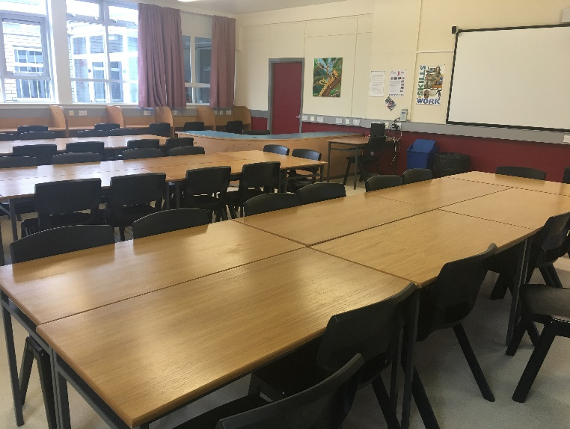

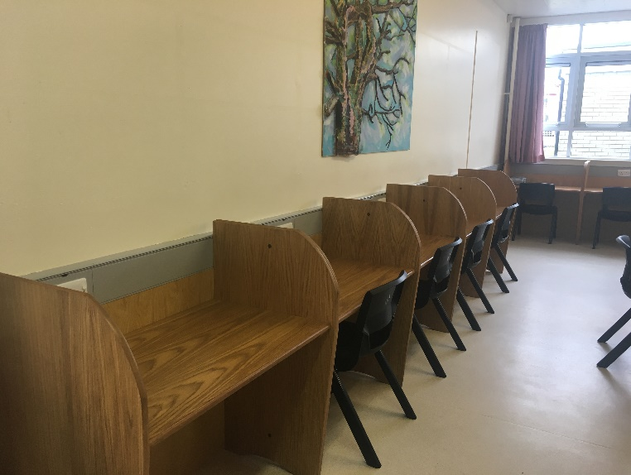

**Sixth Form Learning Centre**

**The Sixth Form Committee**

The Sixth Form Committee assists with the daily running of the Learning Centre and organising key events for Sixth Form. It is their responsibility to ensure that the Centre is treated with respect and they have a responsibility to encourage each member of Sixth Form to be an integral part of College life. Serving on the Sixth Form Committee is an excellent opportunity for students to develop leadership skills, use initiative, motivate others and make a positive impact on College life.

The Committee is made up of 10 students, 4 of whom are selected (i.e. Head Prefects) and 6 are elected through a vote by the student body (4 from Yr 13 and 2 from Yr 14). Elections are held in September each year. The Committee meets twice per term to discuss issues which are relevant to Sixth Form.

**Prefects**

The Prefects at Cullybackey College assist the staff with the smooth running of the College by undertaking supervisory duties and helping with academic subjects and extra-curricular activities.

In Year 14, students act as Prefects by contributing in the above areas and begin to develop and display their leadership potential.

The role of the Prefect is important to:

* Enhance the school life of Cullybackey College pupils;
* Develop personal skills and leadership experience;
* Aid the smooth running of the school.

**Attendance**

All Sixth Form students are expected to aim for 100% attendance.

**Registration takes place at 08:55**. **All students are expected to attend Registration every morning and to be on time**. A register of attendance is also taken every lesson by your subject teachers and the Sixth Form supervisor.

* **Monday–Wednesday: Registration will take place in the registration room at 8.55am. Pupils then attend Numeracy Mentoring or Reading Partners from 9am to 9.15am.**
* **Thursday–Friday: Registration will be taken in registration rooms by the registration teacher at 8.55am. All students have the opportunity to take part in Peer Mentoring on one of these days.**

We expect that you will be in school throughout the normal school day and that you will make every reasonable effort to arrange appointments outside school hours. Attendance at lessons, including supervised study, is monitored by your Registration teachers and Head of Year.

**Apart from lunchtime**, you must remain in the school grounds once you have registered in the morning. Any student who leaves school at other times, without permission, may result in a sanction being imposed.

[](http://www.google.co.uk/url?sa=i&rct=j&q=&esrc=s&source=images&cd=&cad=rja&uact=8&ved=0ahUKEwjc7Mqpu67UAhVQalAKHe4ZBOoQjRwIBw&url=http://www.hamsey.surrey.sch.uk/page/?pid=242&psig=AFQjCNHbhLeP8E8RR9W2r1TzACHcFTlg9w&ust=1497018654762565)If you wish to take on part-time employment, you should be aware that the school recommends a maximum of 8 hours working per week during term-time and preferably at weekends. Experience shows that students who undertake long hours of paid work during the week, under-perform in their academic studies. You are not permitted to be in paid employment between the hours of 08:55 – 15:25, Monday to Friday, except during school holidays.

**Remember - An attendance record of 90% would mean that you have missed up to 4 weeks of lessons over the course of an academic year. Studies show that an attendance record of 90% can reduce your results by up to one grade.**

**Attendance**

**Requesting leave for planned absences:**

These are absences which can be foreseen in advance, and are usually acceptable, but which still require formal authorisation from the school. This includes:

* A medical/dental appointment which could not be arranged outside school hours.
* Religious holiday.
* Interview or visit, e.g. University interview or Open Day.
* Significant extra-curricular activity, such as music drama or sport events not organised by the school.
* Attendance at a funeral.
* Severe disruption to your normal mode of transport.
* Driving test (note that this does not include driving lessons).

**Please bring in a note from your parent/guardian to your Head of Year to request permission for any planned absence.** Requests for a family holiday must be made to the Head of School. Parents do not have the right to take their child out of school for a holiday, but the school may choose to grant authorisation for leave of absence.

**Lateness**

* You must be in time for every class. If you are persistently late, your parent/guardian will be informed and may result in a sanction being imposed.

**Unplanned absence**

These are absences due to illness or other unforeseen circumstances.

* Parent/guardian should telephone the school office on 028 2588 0771 between 08:45 and 09:00 on each day of the absence.
* Parents are asked to email[attendancecullybackeycollege@outlook.com](mailto:attendancecullybackeycollege@outlook.com) to notify school of the reason for the absence.

**Volunteering**

A volunteering program has been created in school to help develop key transferable skills. These skills can be added to your UCAS application, your CV, and employment applications, whilst at the same time contribute to the life of the College and community.

Research by [Deloitte](https://www2.deloitte.com/us/en/pages/about-deloitte/articles/citizenship-deloitte-volunteer-impact-research.html) found that 82 percent of employers are more likely to hire a candidate with volunteering experience. This is because volunteering gives you various skills in hands-on activities that can be applied to your career such as communication skills, commitment, responsibility and other strong leadership skills.

Volunteers are provided with a record book to plan and review achievements and experiences as well as recording the hours worked. Volunteers get a certificate recognising their contribution to volunteering.

Examples of volunteering:

|  |  |
| --- | --- |
| **Within School** | **Within the community** |
| Peer Mentoring | Nursing home |
| Reading Partners | Fold |
| Numeracy Mentoring | Charities |
| School Council | Local primary school |
| Mental Health Ambassador | Youth / sports club |
| Sports coaching | Church |





**Volunteering Opportunities**

**Peer Mentoring Programme**

The Peer Mentoring Programme aims to provide support for key stage 3 students within Cullybackey College. As well as supporting Year 8 pupils as they transition from primary school to secondary school, topics such as communication, anti-bullying and Mental Health are explored and discussed. Mentors are invaluable as they will have experienced the same issues and concerns and can offer support from a young person’s perspective.

**Numeracy Mentoring Programme**

The Numeracy Mentoring Programme aims to support key stage 3 students with Numeracy. Mentors are trained to work with pupils 1:1 on a set of structured activities and games which targets a specific area. This helps the mentee develop confidence and to be able to access numeracy throughout the curriculum.

**Reading Partners Programme**

The Reading Partners Programme aims to support key stage 3 students with Reading. Mentors are trained to work with pupils 1:1 and to ask questions to ensure understanding of the written word. This helps the mentee develop confidence and to be able to access literacy throughout the curriculum.

**School Council**

The Student Council was created to give a voice to young people who attend the College. Through the Student Council, students can contribute to school improvement through the discussion of issues that are important to them. Sixth Form students, who volunteer, are appointed in a leadership capacity to the Student Council to help and guide Year 8-12 pupils in carrying out their Council responsibilities.

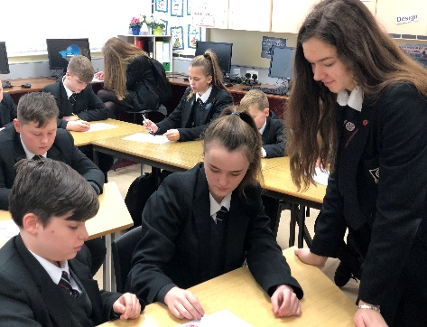**Mental Health Ambassador**

Wellbeing Ambassadors are students who show a real interest in championing positive mental health and wellbeing. Students share their learning around mental health and advertise the importance of self-care. Students support the well-being of their peers by delivering elements of our College Preventative Curriculum.

**Education Maintenance Allowance (EMA)**

**Education Maintenance Allowance (EMA)**

Education Maintenance Allowance is a weekly Government allowance of £30 given to help 16-19 year olds with the costs of further education.

Payments are made every 2 weeks as long as you continue to meet the attendance requirements of:

* Complete all work on time.
* Maintain an attendance rate of 95% or above.
* Provide written parental reason for all absences.

There are also 2 performance based bonuses of £100 normally paid out in January and June.  Getting EMA won’t affect any benefits you or your family already receive.

There are a few conditions that need to be met in order to apply for EMA.  These are highlighted within the application pack which is available from the Head of Year.

|  |  |
| --- | --- |
|  | You can get information about EMA from your Head of Year. You will need to complete an application form. You will be able to get one from:   * [www.nidirect.gov.uk](http://www.nidirect.gov.uk)   30th September 2023 – to be eligible for backdated payments, to the start of term, you must apply before this date.  31st March 2024 – application must be received before this date to be eligible for EMA in 2023/24 but will not be backdated. |

**SIMS Parent App for Home / College Communication**

The College uses SIMS Parent App for **ALL** home/college communication. It is **essential** that parents download the app to receive messages from the College, pupil reports, pupil attendance, pupil assessment scores, timetable and pupil conduct.

In September an email will be sent to you from the college, inviting you to become a SIMS Parent App user. You will receive a registration email from noreply@sims.co.uk containing a unique invitation code. If you do not receive a registration email, please check your SPAM or JUNK folder. You don’t need to make a copy of the code as it will be entered for you.

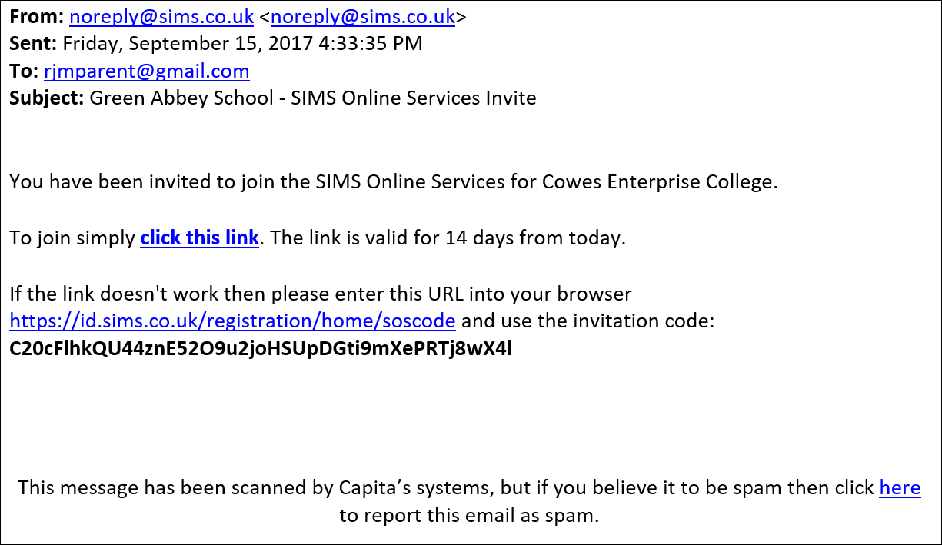

Cullybackey College

Open the email and click the link as instructed. A new Internet browser window will open and you will be asked to Sign in.

Select an existing account of your choice with which you would like to register. Currently, only the options below are available to sign in. If you use a BT or Yahoo email for example, you will need to use another account type from the list below to sign in. Cullybackey College does not see or have any access to the account you use.

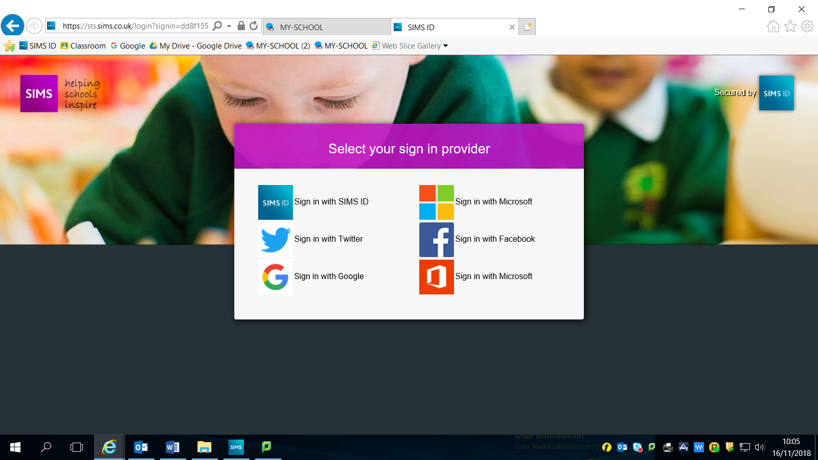Having entered the username and password for the chosen account, you will see the SIMS Registration Form – this should autocomplete, with your name, chosen sign in account and Invitation Code. Select REGISTER.

You will then be asked for the date of birth of one of your children at the school, in the form DD/MM/YYYY (e.g. 07/09/2012). You may be asked for your own date of birth, but please use the date of birth of one of your children.

You have now registered for SIMS Parent. You can download the app from the Google Play or Apple App store by searching for Sims Parent.



**Mobile App**

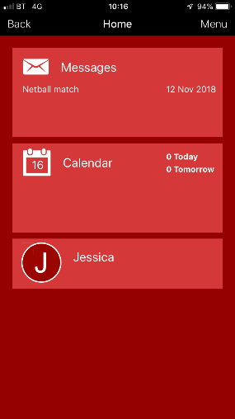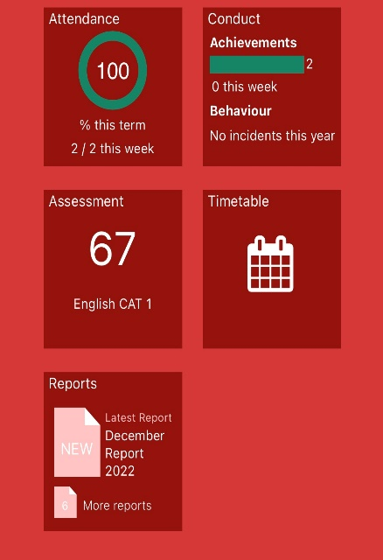

Once you have downloaded SIMS Parent, you will be asked to sign in using your chosen log-in account details. Once you have registered you can also use www.sims-parent.co.uk from any web browser.

**Internet**

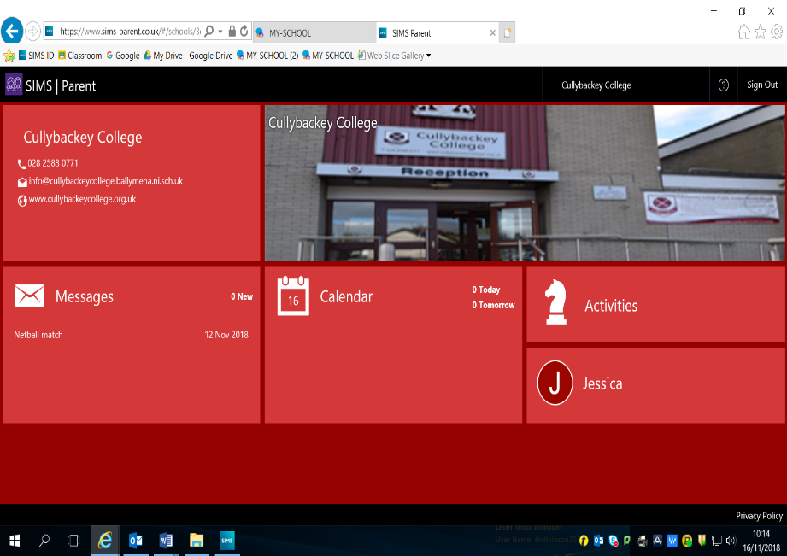

Once logged into the app, you will see a screen with options for: Attendance, Assessment, Timetable, Reports and Conduct. From the homepage you can select which of your children you would like to see details for. Reports will be made available in pdf form so these can be viewed on your phone, tablet or computer.

Key dates can be viewed in the calendar and any messages sent to you will be available under the Messages option.

If you experience any technical difficulties, please contact the school office on   
028 2588 0771.

**The Careers Service**

**The Careers Service**

The Careers Service is based in Careers Annex where you will find:

* **The Careers Office**
* **Careers Room & Library**
* **Interview Rooms**

The Careers Library has many books, university prospectuses and other resources and is open for browsing throughout the school day. The College Library has a section containing Careers books. There are resources on the College Website, while the internet gives you access to a fantastic amount of information. The Careers notice boards are used for Employer and University notices as well as other material relevant to Sixth Form students.

Careers events will be announced in Assembly and in Registration, for example, UCAS speakers, University open days, etc. You will also have a timetabled careers period each fortnight where you will get information, guidance and assistance in University /Employment applications, Personal Statements and CV creation.

There is a work shadowing program which encourages Year 13 students to set up a placement in a career area of interest. The College also sources some placements which can be made available to students. This is a very worthwhile experience, even if you discover something you do not want to do! It develops your knowledge of the workplace and ensures that you interact with other people in a professional environment, which gives you a more realistic idea of the world of work.

Over the next two years you will also need to develop your personal skills and capabilities, perhaps even employability skills. You can do this through your academic subjects, co-curricular activities and extra-curricular activities with the goal of making yourself a well-rounded person and a competitive applicant. Cullybackey College provides lots of activities, both inside and outside the classroom, so make sure you use some of them. There are many activities you can undertake outside school, volunteering in Charity Shops, homework clubs, youth groups or nursing homes. You are not expected to completely fill your time, but you should recognise that you have to be able to say more about yourself than “I like to socialise with my friends”. So go on, join in, find out what interests you, learn a lot and you might even enjoy it!

**Pastoral Care in Sixth Form**

**What is Pastoral Care?**

In Cullybackey College, Pastoral Care refers to the College’s commitment to support the personal, social, emotional and intellectual needs of every pupil, so that each individual can participate fully and gain maximum benefit from everything the College has to offer.

**What does it mean for you?**

You may have been lucky enough to progress through Year 8-12, never needing any extra help or support. This could continue in the Sixth Form. However, unforeseen events can have a major impact on your life and may affect how you feel in school. There will be different issues, pressures and responsibilities in Sixth Form and sometimes students need a helping hand, or just someone to listen to their concerns without passing judgement. If you have any concerns at all, it is important to speak to a member of staff to find out how we can help.

**What about confidentiality?**

Confidentiality is always a priority. However, if you speak to a member of staff about something which might result in serious harm being caused to you or another student, our duty of care means that we must pass the information on to ensure that you will be kept safe.

**Who should I contact?**

|  |  |  |
| --- | --- | --- |
| **Staff** | **Role** | **Room** |
| Mrs S Wright | Head of Senior School | 39 |
| Mrs L Patton | Head of Year 13 | 29 |
| Mrs D Wilkinson | Head of Year 14 | CRS |
| Mr C McLaren | Designate Child Protection | 73 |
| Mrs P Roulston | Deputy Designate Child Protection | Senco Office |

**OR ANY OTHER TEACHER IN THE COLLEGE**

If you are worried or upset, don’t ignore problems in the hope that they will disappear. Please speak to a member of staff. In addition, **we can arrange sessions on site with an independent, professional counsellor from Family Works Counselling**. Counselling may help you to understand what you think, feel and do; to weigh up your alternatives and options, make your own decisions and act upon them

**Cullybackey College**

**Pupil School Holidays**

**2023-2024**

**1st Day of Term**

**Year 13** Wednesday 30 August 2023  **(½ day - 12.15pm finish)**

**Year 14** Thursday 31 August 2023  **(½ day - 12.15pm finish)**

**Whole School** Friday 1 September 2023 (**3.25pm finish)**

**Prize Day** Friday 22 September 2023 **(1 day)**

**Autumn Half Term** Monday 30 October 2023 -   
 Monday 6 November 2023 **inclusive** **(6 days)**

**School Closure** Friday 1 December 2023 **(1 day)**

**Christmas 2023** Wednesday 20 December 2023 **(½ day - 12.15pm finish)** -

Wednesday 3 January 2024 **inclusive (10 days)**

**School Closure** Friday 12 January 2024 **(1 day)**

**Open Nights** Monday 15 January 2024 **(½ day - 12.15pm finish)**

Tuesday 16 January 2024 **(½ day - 12.15pm finish)**

**School Closure** Friday 26 – Monday 29 January 2024 **inclusive (2 days)**

**Spring Half Term** Monday 12 – Monday 19 February 2024 **inclusive**  **(6 days)**

**School Closure** Monday 18 March 2024 **(1 day)**

**Easter 2024** Tuesday 26 March 2024 **(½ day - 12.15pm finish)** -

Wednesday 10 April 2024 **inclusive**  **(11 days)**

**May Day Holiday** Monday 6 May 2024 **(1 day)**

**Bank Holiday** Monday 27 May 2024 **(1 day)**

**School Closure** Friday 21 June 2024 **(1 day)**

**End of School Year** Friday 28 June 2024 **(½ day - 12.15pm finish)**

***While most of the above dates are fixed there are some which may be changed subject to other***

***demands in school.***

**Cullybackey College**



**Contact Information**

Address: Cullybackey College

44 Pottinger Street

Cullybackey

Co Antrim

BT42 1BP

Phone Number: 028 2588 0771

Website: [www.cullybackeycollege.org.uk](http://www.cullybackeycollege.org.uk)

Email: [info@cullybackeycollege.org.uk](mailto:info@cullybackeycollege.org.uk)

Attendance: [attendancecullybackeycollege@outlook.com](mailto:attendancecullybackeycollege@outlook.com)

***per angusta ad augusta***