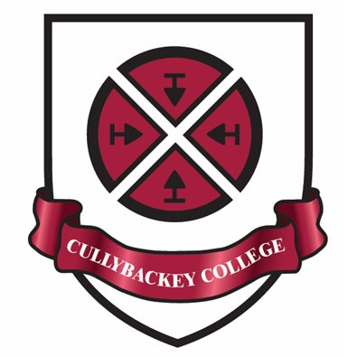
Cullybackey College
Pupil School Holidays
2022-2023

1st Day of Term Wednesday 24 August 2022 - Yr 8 Only (½ day - 12.30pm finish)
Thursday 25 August 2022 - Yr 8 Only (½ day - 12.30pm finish) Friday 26 August 2022 - Yr 8 Only (½ day - 12.30pm finish)
Tuesday 30 August 2022 - Yr 8 Only (½ day - 12.30pm finish)
Wednesday 31 August 2022 - Yr 13 &14 Only (½ day - 12.30pm finish)
Thursday 1 September 2022 - All Year Groups to attend

Prize Day Friday 23 September 2022 (1 day)

School Closure Monday 26 September 2022 (1 day)

Autumn Half Term Monday 31 October 2022 -
Friday 4 November 2022 inclusive (5 days)

School Closure Friday 2 December 2022 (1 day)

Christmas 2022 Wednesday 21 December 2022 (½ day - 12.15pm finish) -
Wednesday 4 January 2023 inclusive (10 days)

School Closure Friday 13 January 2023 (1 day)

Open Nights Monday 16 January 2023 (½ day - 12.15pm finish)
Tuesday 17 January 2023 (½ day - 12.15pm finish)

Spring Half Term Monday 13 - Friday 17 February 2023 inclusive (5 days)

School Closure Friday 17 March 2023 (1 day)

Easter 2023 Wednesday 5 April 2023 (½ day - 12.15pm finish) -
Wednesday 19 April 2023 inclusive (10 days)

May Day Holiday Monday 1 May 2023 (1 day)

King’s Coronation Monday 8 May 2023 (1 day)

Bank Holiday Monday 29 May 2023 (1 day)

School Closure Friday 16 June 2023 (1 day)

End of School Year Friday 30 June 2023 (½ day - 12.15pm finish)

While most of the above dates are fixed there are some which may be changed subject to other
demands in school.

